**Home view:**

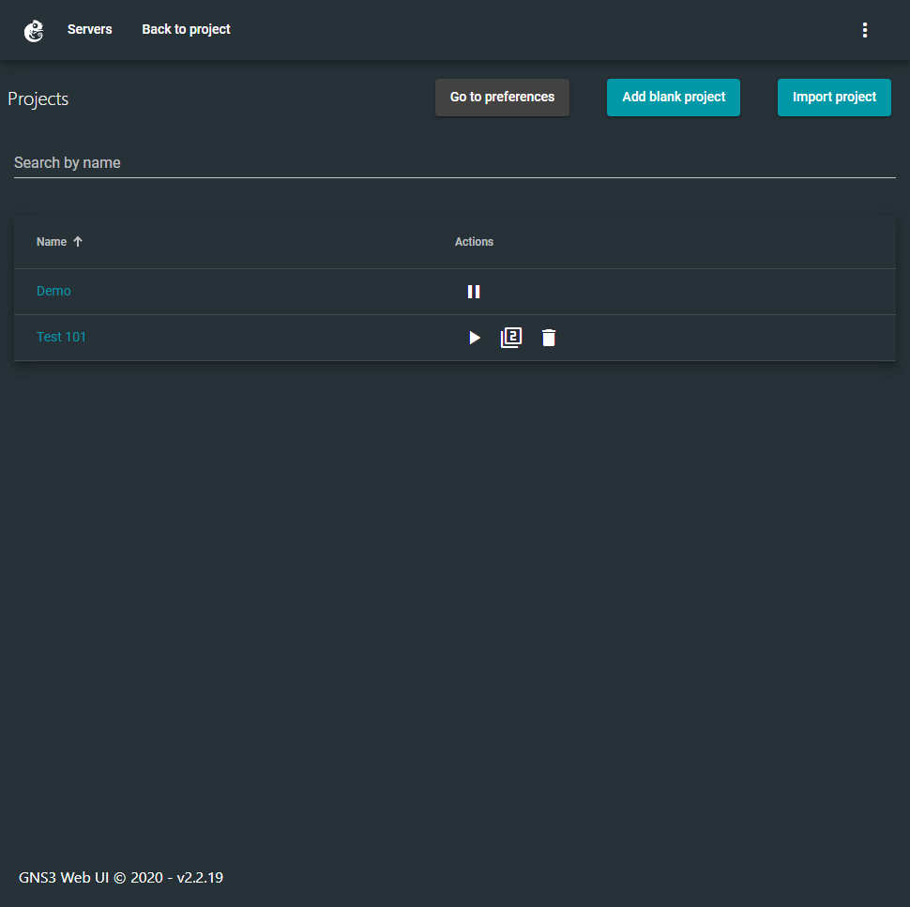

* To start a new project click add blank project
* Listed are the existing project on your server
* A Project is equivalent to one virtual environment
* Project nodes will continue to run even when you leave or close the page unless stopped or suspended
* You can suspend a project with the pause button (this will free up Virtual resources)
* If suspended, you can start it with the paly button duplicate it with the 2nd button and delete it with the 3rd button
* To open a project simply click its name

**Project view:**

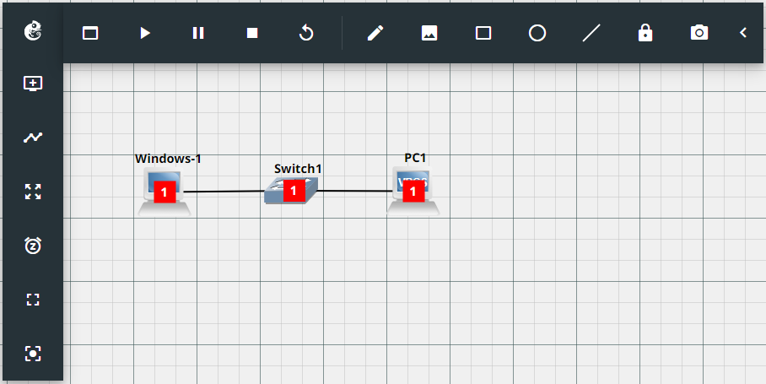**Top Row left to right:**

* GNS3 logo: opens a menu to navigate the server and change general settings
* Console box: opens the web console to all active devices
* Play: Powers on all devices
* Pause: Suspends all devices
* Stop: Powers off all devices
* Reload: Dose a hard Reboot of all devices
* Pencil: allows the creation of a text box for notes
* Image: allows for the insert of images
* Shapes: allows you to draw a square circle or line respectively
* Lock: Locks the orientation of the network
* Camera: takes a screen grab of the network

**Left side bar top to bottom:**

* Add node: opens the drag and drop menu used to create new devices on your network
* Link: allows you to connect ports similar to Packet Tracer
* Moving mode: Enable/disables moving all nodes across the background instead of with it
* Clock: Take and Save snapshots of the network
* Fit view: Centers the view and size on the nodes
* Center view: Centers the view on the background

**Project:**

* Images: These are the virtual nodes that run on the network
* Thick Black line: This represents a hard network connection
* Red box with a number: This represents the Layer
* Grid: The project background

Individual Node manipulation (Menu opened via right click)  
*Some options may not be available on all devices

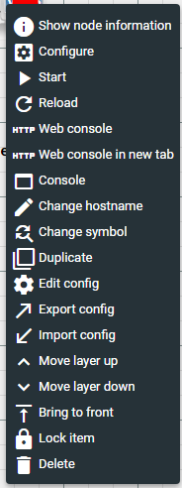

**Map Topology:**

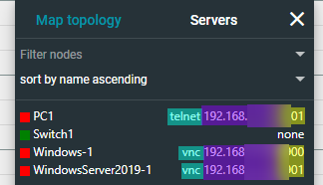

* From left to right
* color indicator for node power state
* node name
* mode of connection
* IP to connect on
* Port to connect with